Temasek Polytechnic
School of Informatics and IT

Diploma in Information Technology (IT)

Project Plan

Project Particulars

Tutor | Qi Yutao
Class | P01
Project Title | Delonix Regia Hotel Management System

Project Team’s Particulars

Matric Number | Student Name
1603625C | Ch’ng Wai Kit Wesley
1601553I | Yip Xiu Han
1601705E | Qamarul Fattah Bin Hamdan
1605815H | Chan Kei On

Revision History

Date | Version | Description | Author
25/10/17 | 1.0 | Initial Drafting | Xiu Han, Qamarul
31/10/17 | 1.1 | Adding Assumptions | Xiu Han, Wesley, Qamarul
7/11/17 | 1.2 | Final Revision | Kei On

Table of Contents

- Introduction
  - Objectives and scope of the project
  - Assumptions and constraints
  - Definitions and acronyms

- Roles and responsibilities

- Estimates and project schedule
  - Work breakdown structure
  - Project schedule
  - Budget summary

- Risk management plan
Project Plan

1 Introduction
1.1 Objectives and scope of the project

Our group comprising of four members has been assigned to work in Pantheon Systems, a small software development firm as part of our Student Internship Programme (SIP). The purpose of the project is to develop a hotel management system for Delonix Regia, a small hotel that is managed by a middle-aged couple, Mr. and Mrs. Wang, as even though it is located at a reasonably good district, it has not been doing well.

There are several objectives that this project aims to achieve to fulfil the purpose of this project.

Technical

1) Develop an online reservation module where customers can book the hotel rooms from their own home. This is to ensure convenience to the customers and to provide visibility to the customers on which hotel rooms are available on certain dates and to help calculate the total cost of the booking.

2) Develop a room management module in which employees can easily check the status of each hotel room if it is booked, under renovation or requires maintenance and help organize housekeeping activities.

3) Develop an inventory management module where employees can keep track of each item that the hotel has such as cleaning supplies and toiletries. This is to ensure that the hotel can maintain specific numbers of items to serve their customers without having to overstock.

4) Develop an employee management module in which the owners of the hotel can maintain records of their employees such as employee information, payroll, perks, incident reports, position and working hours. This helps the owners of the hotel to know always who is working on specific days and ensures that the employees get paid correctly based on their salary and bonuses. Having a single module makes it easier for the owners to manage employee information as there is no need for the owners to look for other sources to update records.

5) Ensure that new and existing data are backup onto a server or a cloud to ensure that important data don’t get lost and synchronise to backup daily.

Non-Technical

1) Since the owners of the hotel are a middle-aged couple, the hotel management system must be user friendly to not cause confusion and frustration for the owners as they might not be familiar with the technology.

2) To help employees to efficiently perform daily administrative tasks using the hotel management system to manage important data instead of using pen and paper.

3) To increase the profits of the hotel by implementing the hotel management system to reduce the amount of office supplies needed to perform their daily tasks.

The project is expected to be delivered with several features:

Room Management Module (RMM) (Xiu Han):
The Room Management Module (RMM) helps the front office of Delonix Regia with designating rooms as well as with housekeeping. The RMM allows the rooms’ status to be identified, thus assisting the staff in assigning available rooms to new guests. By providing the staff with in-house guest information such as when guests check-in and check-out, the RMM makes organizing housekeeping activities much easier by knowing which rooms are vacant at any given time and prioritizing them.

Inventory Management Module (IMM) (Qamarul):
The Inventory Management Module will allow the hotel staff to keep track of inventories such as toiletries, and cleaning supplies. The hotel staff will be able to view current stock of toiletries and cleaning supplies using IMM. This will ensure that the stock level of the supplies is well maintained, thus saving costs for the hotel as they will be able to know when to purchase more supplies when necessary. The IMM also provides an order management function in which if customers order room service, the system can track what kind of order is made, where is the location the ordered is to be delivered and how much does the order cost. This ensures visibility on all orders made by customers in the hotel which prevents orders getting mixed up or customers not getting their orders.

Employee Management Module (EMM) (Kei On):
The Employee Management Module will allow the owners to keep track and maintain all records of current employees working in the hotel. The module has a payroll system in which it calculates the amount of pay an employee receives based on salary, benefits and bonuses keeping it accurate and consistent. The module will also keep track on the number of employees working on a specific department or section of the hotel such as the front desk.

Online Reservation Module (ORM) (Wesley):
The Online Reservation Module (ORM) allows customers to book hotels online. The module allows customers to view the description, prices, photos, vacancy of the hotel rooms. It also allows the customers to choose from different “tiers” of the rooms they want (E.g. Gold, Premium Rooms). The customers can specify the amount of people staying in the room and make payment methods using credit card transactions online. The ORM also allows the owners/employees of Hotel Delonix Regia to create, retrieve update and delete room/hotel information on their website.

1.2 Assumptions and constraints

Assumptions

We assume that Mr. and Mrs. Wang wants the hotel management system due to booking and administrative duties such as employees’ payroll and inventory management are written on paper. This leads to inefficiency as customers would either call the hotel or physically be there to book a room at the hotel which is inconvenient for the customers as compared to an online booking system as it lacks visibility on which hotel rooms are available on certain dates. Employees would have to spend time looking through piles of paper to find the information needed which will slow down response time. Records are susceptible to natural hazards such as fires or floods, which could lead to a loss in accountability, as opposed to if the information was stored online on the cloud. Furthermore, the hotel is required to spend money by buying paper, ink cartridges and other office supplies to create these physical records which decrease the profits the hotel earns. Therefore, the hotel management system requires several modules to address the problems faced by the hotel.

We assume that the hotel would need to keep track of the inventory to properly supply the rooms with item such as toiletries or bedsheets. Therefore, an Inventory Management Module is to be developed to allow the hotel staff to keep track of inventories.

We can also assume that the rooms in the hotel need daily cleaning and if there are any problems with the room, the staff must be able to clean the room quickly. Therefore, a Room Management Module is to be developed to allow the rooms’ status to be identified, thus assisting the staff in assigning available rooms to new guests. By providing the staff with in-house guest information such as when guests check-in and check-out, the Room Management Module makes organizing housekeeping activities much easier by knowing which rooms are vacant at any given time and prioritizing them.

We can assume that Mr. and Mrs. Wang have other employees that work within the hotel. Therefore, the Employee Management Module is to be developed will allow the owners to keep track and maintain all records of current employees working in the hotel.

We can assume that since Mr and Mrs. Wang does room booking manually, it means that customers can only book the hotel when they are there. This means less profits as customers would not want the hassle of arriving at the hotel, only to find out that there are no vacancies. Therefore, The Online Reservation Module is to be developed to allows customers to book hotels online.

Since each member of the development team has their own PCs and Microsoft office, there is no need to purchase additional PCs or copies of Microsoft office.

Constraints

Group
1) Members have different schedules and therefore may not be able to meet as a group to update on each other’s progress.

2) The project is to be finished in eight weeks.

3) Due to the hotel not doing well, the budget for this project might be constrained.

Individual
Room Management Module (RMM) (Xiu Han):
Since the RMM helps to automate the recording process of room statuses instead of being completely independent and automatic, some information might still be inaccurate; For example, if a guest forgets to check-in or out.

Inventory Management Module (IMM) (Qamarul):
This module is not accessible to the public. Only the hotel’s management team will be able to access this module. Since the IMM is not an automated inventory management system, there may be inaccuracy in terms of its data. The hotel staff will have to manually key in the inventory stock, which is prone to human error, thus leading to inaccurate data.

Employee Management Module (EMM) (Kei On):
The public does not have access to this module as it concerns personal information of the employees. Even then, not all employees are allowed access to the module, only the owners or employees that have administrative rights can access the module. The EMM’s payroll system will only show the local currency of the country the hotel is in.

Online Reservation Module (ORM) (Wesley):
This module is constrained as everything is done online. Customers may or may not have the privilege of Internet Access and therefore are unable to book rooms online. In the event of an Internet outage be it on the network provider or the company's’ end, the online booking module may be unavailable and cause employees to be unable to update hotel information and customers to be unable to book rooms online.

1.3 Definitions and acronyms

SIP - Student Internship Programme
HMS - Hotel Management System
TOR - Terms of Reference
SDLC - Software Development Life Cycle
PC - Personal Computer
SQL - Structured Query Language
IMM - Inventory Management Module
EMM - Employee Management Module
ORM – Online Reservation Module
RMM – Room Management Module

2 Roles and responsibilities

Members | Roles
Kei On | Scrum Master, Software engineer
Wesley | Product Owner, Software engineer
Xiu Han | Software engineer
Qamarul | Software engineer

Members | Objectives/Deliverables
All | PP Section 1.1 - Objectives and scope of the project
All | PP Section 1.2 - Assumptions and constraints
Xin Han | PP Section 1.3 – Definitions and acronyms
Qamarul | PP Section 2 – Roles and Responsibilities
Kei On | PP Section 3.1- Work breakdown structure
Kei On | PP Section 3.2 – Project Schedule
Kei On | PP Section 3.3 – Budget Summary
Wesley | PP Section 4 – Risk Management Plan
Wesley | Preparation Phase – Gathering user requirements
Wesley | Preparation Phase - Prioritize User Stories
All | Sprint #1 - Develop EMM: Payroll System Function
Xiu Han, Qamarul | Sprint #1 - Develop EMM: CRUD Employee Records Function
Kei On, Wesley | Sprint #1 - Develop EMM: Search Function
All | Sprint #2 - Develop ORM: Payment Function
Kei On, Qamarul | Sprint #2 - Develop ORM: Book Hotel Room Function
Wesley, Xiu Han | Sprint #2 - Develop ORM: CRUD Hotel Room Function
Kei On, Xiu Han | Sprint #3 - Develop RMM: Room Status Function
Wesley, Qamarul | Sprint #3 - Develop RMM: Housekeeping Function
Wesley, Qamarul | Sprint #4 - Develop IMM: CRUD Inventory Function
All | Sprint #4 – Develop IMM: Order Management Function

3 Estimates and project schedule
3.1 Work breakdown structure

Preparation Phase | People responsible for the task | Days needed to complete
Gathering User Requirements | Wesley | 1 Day
Prioritize User Stories | Wesley | 1 Day
Sprint Planning Meeting | Kei On | 1 Day
Complete Term of Reference | All | 12 Days
Complete Project Plan | All | 12 Days
Objective Milestone
Sprint #1
Develop EMM: Payroll System Function | All | 10 Days
Develop EMM: CRUD Employee Records Function | Xiu Han, Qamarul | 5 Days
Develop EMM: Search Function | Kei On, Wesley | 5 Days
Sprint #1 Complete
Sprint #2
Develop ORM: Payment Function | All | 10 Days
Develop ORM: Book Hotel Room Function | Kei On, Qamarul | 7 Days
Develop ORM: CRUD Hotel Room Function | Wesley, Xiu Han | 5 Days
Sprint #2 Complete
Sprint #3
Develop RMM: Room Status Function | Kei On, Xiu Han | 6 Days
Develop RMM: Housekeeping Function | Qamarul, Wesley | 6 Days
Sprint #3 Complete
Sprint #4
Develop IMM: CRUD Inventory Function | Qamarul, Wesley | 5 Days
Develop IMM: Order Management Function | All | 7 Days
Sprint #4 Complete

3.2 Project Schedule

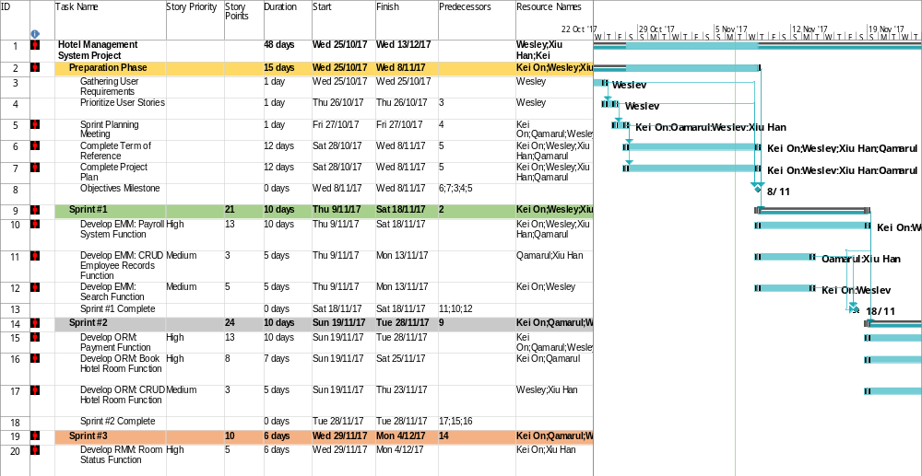

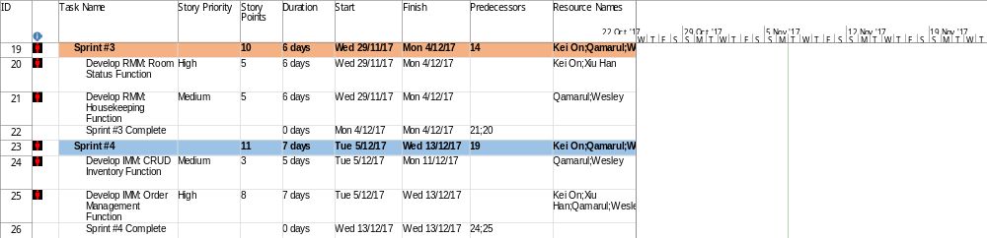

3.3 Budget Summary

Hardware Cost
4 PCs (The development team has their own PCs) – S$0
1 Canon PIXMA MG2570S (Printer/Scanner) – S$59
1 Lenovo ThinkServer TS140 (Application Server) – S$680
Total Hardware Cost – S$739

Software Cost
4 copies of MySQL Community Server – S$0
4 copies of Microsoft Visual Studio - $499 x 4 = S$1996
4 copies of Microsoft Office – S$0
1 copy of Microsoft Project - S$1,799
Total Software Cost – S$3795

Manpower Cost
Average Salary of software engineer in Singapore – S$4156 per month
Project duration is 2 months: 4156 x 2 = S$8312
Total Manpower Cost: 8312 x 4 = S$ 33,248
Budget needed for project: S$33,248 + S$3795 + S$ 739 = S$37,782

4 Risk Management Plan

Type of Risk | Severity of impact | Likelihood of occurrence | Risk Exposure | Reduction Strategy
Customer insisting on major dynamic changes of the requirements of the project. | High (3) | High (3) | 9 | Ensure that the client’s requirements are made very clear through contractual means. However, due to the development team using Scrum, every iteration cycle we are able to demo the project and adjust accordingly to the customer’s needs.
Developer Resignation/Retrenchment | High (3) | Low (1) | 3 | Ensure that there are capable employees on standby to take on the project in the resignee’s stead.
Unclear/Misunderstood Project Specifications | Medium (2) | High (3) | 6 | As the development team is using Scrum, we are able to adjust the development of the project by shifting the item to the next sprint cycle if part of the project specifications is misunderstood.
Funding Cut (Bankruptcy) | High (3) | Medium (2) | 6 | Ensure that a stable payment contract is made based on each stage of the software’s development. With Scrum, the development team will be able to finish a potentially shippable product which the hotel can use to earn revenue.
Lack of Resources | Medium (2) | Low (1) | 2 | Ensure that the project budget is meetable before developing the software.
Data Loss | High (3) | Low (1) | 3 | Have both local and cloud backups while developing the software.

